**Module (Bootstrap Basic & Advanced) – 6**

* **What are the advantages of Bootstrap?**

- In brief, the advantages of Bootstrap include:

- 1. Responsive Design: Easily create mobile-friendly websites.

- 2. Pre-designed Components: Save time with pre-made UI elements.

- 3. Consistency: Maintain a uniform look and feel.

- 4. Customization: Adapt Bootstrap to your project's needs.

- 5. Cross-browser Compatibility: Ensure compatibility with major browsers.

- 6. Community Support: Access a large developer community and resources.

- 7. Accessibility: Build inclusive websites with built-in accessibility features.

- 8. Speed of Development: Quickly prototype and develop projects.

- 9. Mobile-first: Prioritize mobile design for modern usage.

- 10. Thorough Testing: Reliable and tested codebase.

- 11. Open Source: Free to use for both personal and commercial projects.

- 12. JavaScript Integration: Easily incorporate JavaScript functionality.

    -----

* **What is a Bootstrap Container, and how does it work?**

- A Bootstrap container is a core layout element in the Bootstrap framework used to structure and manage the placement of content on a web page. It works by:

* 1. Providing Structure: Containers create a defined area on the web page where you can place content, ensuring a consistent layout.
* 2. Responsive Design: Bootstrap containers automatically adjust their width based on the screen size, making your content look good on various devices.
* 3. Centering Content: They center content horizontally within the container, enhancing readability and aesthetics.
* 4. Adding Margins: Containers apply padding to the left and right, maintaining proper spacing between content and the edges of the screen.
* Overall, Bootstrap containers help developers create responsive and visually appealing web layouts with ease.

    ----

* **What are the default Bootstrap text settings?**

- Bootstrap's default text settings include:

* 1. Font Family: A clean, sans-serif font stack ensures readability.
* 2. Font Size: Provides predefined sizes for headings, paragraphs, and more.
* 3. Line Height: Sets consistent spacing between lines of text.
* 4. Font Weight: Assigns appropriate weights to headings and content.
* 5. Text Color: Typically, dark text on a light background.
* 6. Text Alignment: Supports left, right, center, and justified alignment.
* 7. Text Decoration: Handles underlines and strikethroughs for links.
* 8. Text Transformation: Options for uppercase, lowercase, or capitalization.
* 9. Text Wrapping: Manages word wrapping and overflow.
* 10. Responsive Scaling: Adjusts text size for different screen sizes.

    ----

* **What do you know about the Bootstrap Grid System?**

- The Bootstrap Grid System is a powerful layout system that simplifies web page design:

* 1.12-Column Grid: It divides the page into 12 equal-width columns, providing a flexible foundation.
* 2.Responsive: The grid adjusts automatically to different screen sizes, thanks to CSS media queries.
* 3.Containers: Bootstrap uses `.container` and `.container-fluid` to wrap content and control its width.
* 4. Rows: Rows create horizontal groups of columns, ensuring proper alignment.
* 5. Columns: `.col-*` classes define the content's width and positioning within columns.
* 6.Nesting: You can nest rows and columns within each other to create complex layouts.
* 7.Offsetting: Columns can be offset to create spacing or adjust alignment.
* 8.Alignment: Bootstrap offers alignment classes for vertical and horizontal content positioning.
* 9.Responsive Classes: Special classes allow you to control column behavior on different screen sizes.
* 10.Grid Flexibility: The Bootstrap Grid System is a cornerstone of responsive web design, making it easier to create versatile and visually appealing layouts.

    ----

**\* What is the difference between Bootstrap 4 and Bootstrap 5?**

- Here are the key differences between Bootstrap 4 and Bootstrap 5:

* 1. Customization: Bootstrap 5 promotes customization with utility classes, while Bootstrap 4 relies more on predefined classes.
* 2. jQuery Dependency: Bootstrap 5 gradually reduces jQuery dependency, favoring native JavaScript, while Bootstrap 4 uses jQuery for many components.
* 3. Browser Support: Bootstrap 5 drops support for older browsers like Internet Explorer 10 and 11, focusing on modern ones, whereas Bootstrap 4 supports a broader range of browsers.
* 4. Documentation: Bootstrap 5 revamped documentation for clarity and usability compared to Bootstrap 4.
* 5. Theming: Bootstrap 5 introduces a new theming system with CSS custom properties, simplifying theme creation, while Bootstrap 4 has a traditional theming approach.
* 6. Font Icons: Bootstrap 5 ditches Glyphicons, suggesting external icon libraries like Font Awesome, while Bootstrap 4 includes Glyphicons.
* 7. Grid System: Bootstrap 5 refines the grid system for improved spacing and alignment, aligning with modern design practices, while Bootstrap 4 has a slightly different grid system.
* 8. File Size: Bootstrap 5 optimizes file sizes for better performance and loading speed, aiming for a smaller footprint, while Bootstrap 4 has larger file sizes.
* 9. JavaScript Plugins: Bootstrap 5 encourages native JavaScript for components, reducing jQuery reliance, while Bootstrap 4 heavily relies on jQuery for many functionalities.
* 10. Utility-First Approach: Bootstrap 5 embraces a utility-first approach, allowing direct application of styles to HTML elements using classes, while Bootstrap 4 uses more predefined classes for styling.

    ----

* **What is a Button Group, and what is the class for a basic Button Group?**

- A Button Group in Bootstrap is a component that groups a set of buttons together, allowing users to select one option from the group. Button groups are commonly used for options like radio buttons or checkboxes where only one selection is allowed within the group.

* The class for creating a basic Button Group in Bootstrap 4 and Bootstrap 5 is `.btn-group`. You can use this class to wrap a group of button elements. The following is an example of a basic button group in Bootstrap:

```html

<div class="btn-group" role="group" aria-label="Basic example">

<button type="button" class="btn btn-primary">Button 1</button>

<button type="button" class="btn btn-primary">Button 2</button>

<button type="button" class="btn btn-primary">Button 3</button>

</div>

```

* In this example, the `btn-group` class is applied to a `div` element, which contains a group of buttons. You can further style and customize the button group as needed, and Bootstrap provides additional classes and options for more advanced button group features like toggling and sizing.

    ---

* **How can you use Bootstrap to make thumbnails?**

- To create thumbnails in Bootstrap, you can use the `.thumbnail` class. Here's a brief overview of how to use Bootstrap to make thumbnails:

- 1. Wrap your image or content inside a `div` element.

- 2. Apply the `.thumbnail` class to this `div`.

- 3. Add your image or content within the `div`.

* Example:

```html

<div class="thumbnail">

<img src="your-image.jpg" alt="Thumbnail Image">

<!-- or you can add content here -->

</div>

```

* You can customize the styling further using CSS or Bootstrap classes to adjust the size, padding, and other aspects of your thumbnails to suit your design. Thumbnail components are often used to display images or content in a visually appealing and organized manner.

    ----

* **In Bootstrap 4, what is flexbox?**

- In Bootstrap 4, flexbox refers to the use of the CSS Flexible Box Layout module (Flexbox) to create flexible and responsive layouts. Flexbox is a layout model that simplifies the alignment and distribution of elements within a container, making it easier to create responsive designs. Bootstrap 4 utilizes flexbox extensively for its grid system and other layout components, enabling developers to build responsive and visually appealing web applications with ease. Flexbox helps control the positioning, sizing, and alignment of elements within a grid or container, ensuring consistent and adaptive layouts across various screen sizes and devices.

    ----

* **How can one create an alert in Bootstrap?**

- To create an alert in Bootstrap, use the `<div>` element with the `alert` class and an additional contextual class for the desired style (e.g., `alert-success`, `alert-warning`, `alert-danger`). You can add text and optional dismiss buttons. Here's a brief example:

```html

<div class="alert alert-success">

This is a success alert.

</div>

```

* You can further customize alerts with icons, buttons, and dismiss functionality as needed.

    ----

* **What is a bootstrap card and how would you create one?**

- A Bootstrap card is a flexible and customizable container component in the Bootstrap front-end framework used to display various types of content, such as text, images, links, and more, in a structured and visually appealing way. Cards are designed to present information in a concise and organized manner, making them suitable for displaying articles, product listings, user profiles, and other content on web pages. They can be easily styled and customized using Bootstrap classes to match the design of your website or application. Bootstrap cards provide a responsive and consistent layout, making them a valuable tool for creating visually appealing and responsive user interfaces.

* Code:

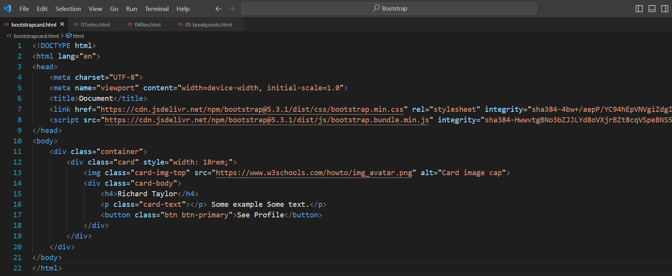

* Output:



    